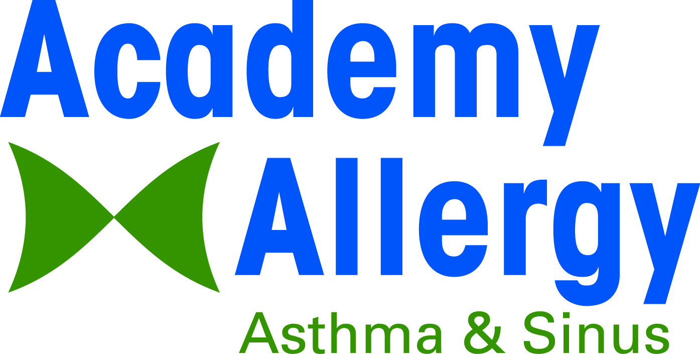

Welcome to Academy Allergy Asthma & Sinus!

Thank you for choosing Academy Allergy Asthma and Sinus, PC. We look forward to providing you with the best medical care for your allergy, asthma and immunology problems. You have put your trust in us to make the best diagnoses and treatment plan for you. In order to do so, we need your help in providing essential information through our registration forms. If you have any questions about our forms or your appointment please call the office. We encourage you to visit our website for more information about our practice and providers.
What to bring to your appointment:

Completed Registration Form and Patient Consent Agreement

Medication List including Dosage and Frequency

Insurance Card and a Photo ID
- Appropriate X-Rays and Laboratory Reports

We also encourage you to confirm your insurance benefits prior to your visit as it is our policy to collect your portion of the cost at the time of service. We have provided some common procedure codes used in our office to assist you in obtaining correct coverage information.

Name of Procedure | CPT Code | Covered by Insurance | Procedure covered by copay or deductible | Amount Patient will be responsible to pay
Office Visit | 99204
Allergy Skin Testing | 95004
Allergy Injections | 95117
Allergy Serum | 95165
Spirometry | 94010

Please arrive at least 15 minutes early to allow our staff to complete your registration. If you need to cancel your appointment, please give us 24 hours notice so we can offer your appointment time to someone on our waiting list. We also ask that you not wear any perfume or cologne in our office.

Allergy Testing Procedures
Based on your symptoms, we may find it necessary to perform tests such as allergy skin testing. Skin testing is performed by applying allergens to the skin and lightly pricking. The results may be raised, red, itchy spots which will appear within 15 to 20 minutes after being pricked. This reaction is similar to a mosquito bite and usually disappears within several days after testing. Reactions can indicate which allergens may be causing your symptoms.

In preparation for your exam, please do not take any cold or sinus medications or antihistamines for five days prior to your appointment and the day your appointment do not apply any lotions to your arms if we are doing testing.

